**Lab - Examining Telnet and SSH in Wireshark**

**Ali Ashkeyev 18BD11079**

**Objectives**

**Part 1: Examine a Telnet Session with Wireshark**

**Part 2: Examine an SSH Session with Wireshark**

**Part 1: Examining a Telnet Session with Wireshark**

1. Loopback:Io

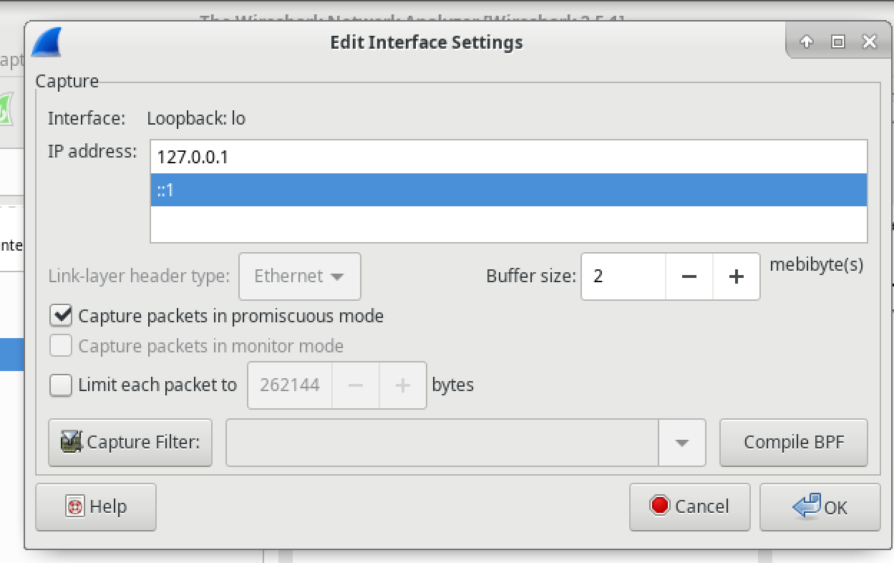

1. Start telnet session

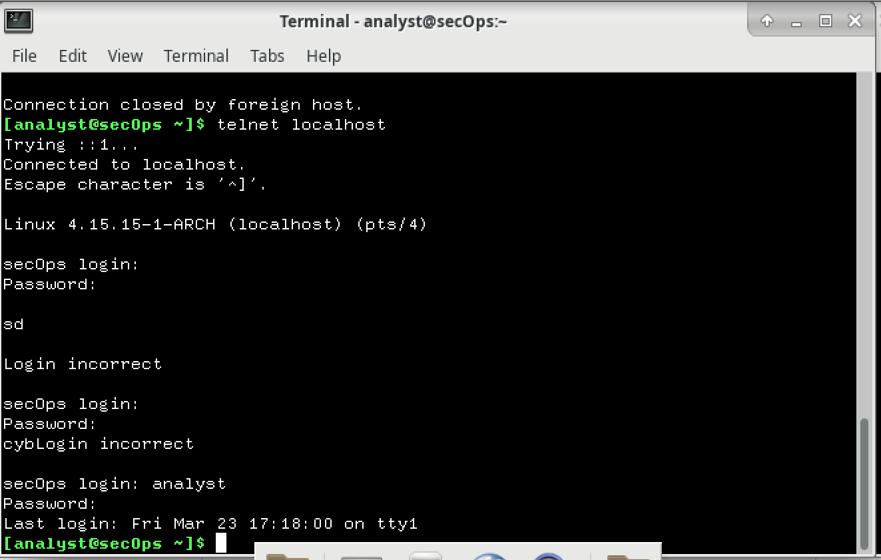

**Step 2: Examine the Telnet session.**

1. Apply telnet filer

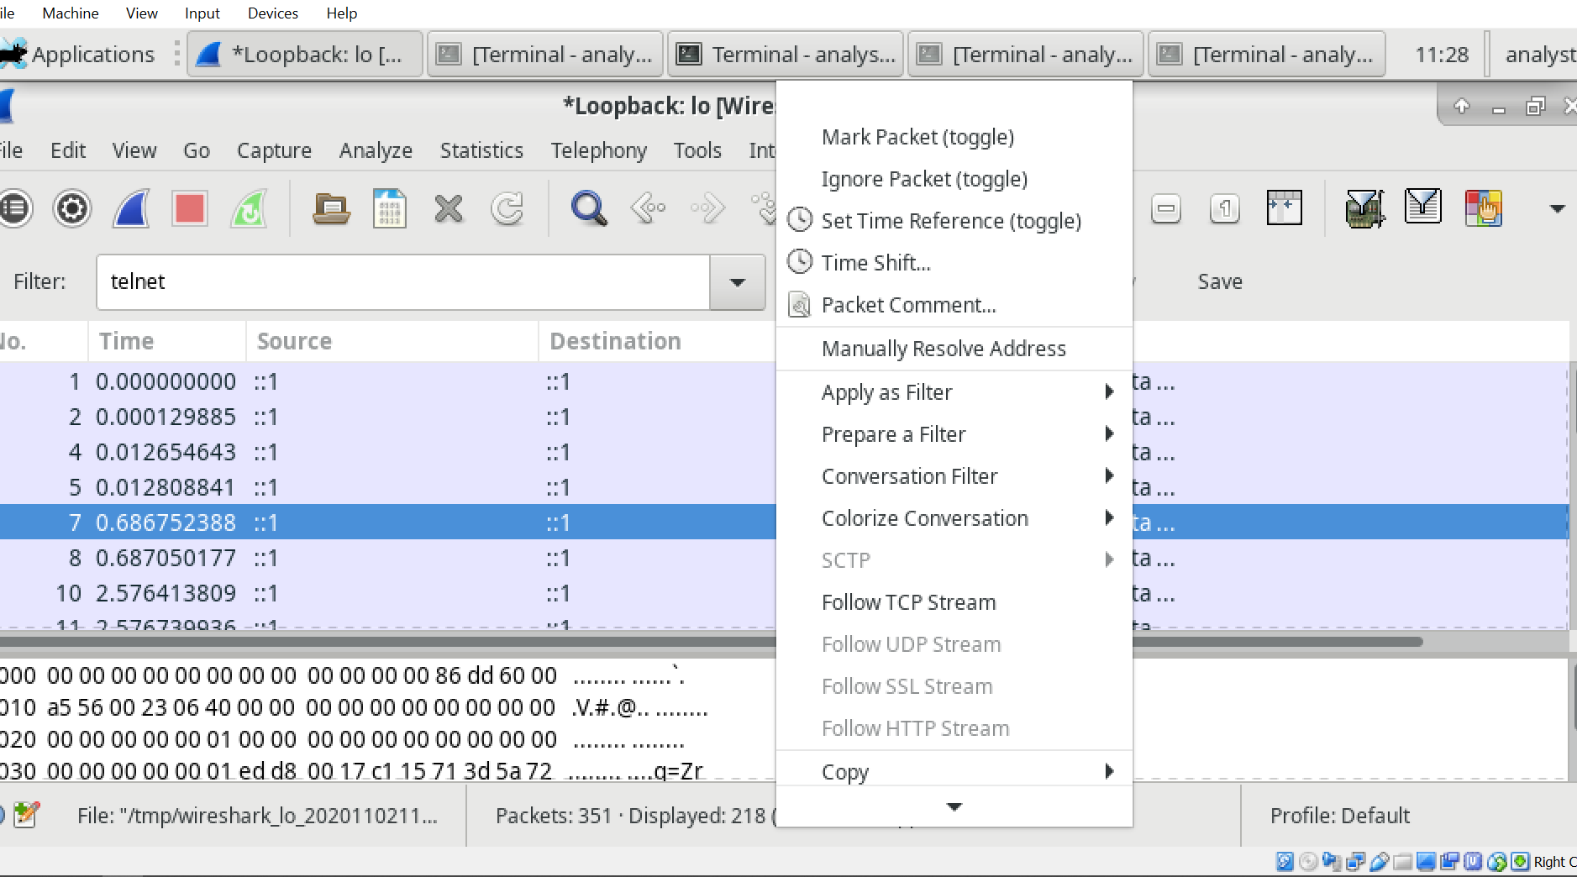

1. Data for Telnet session with login and password

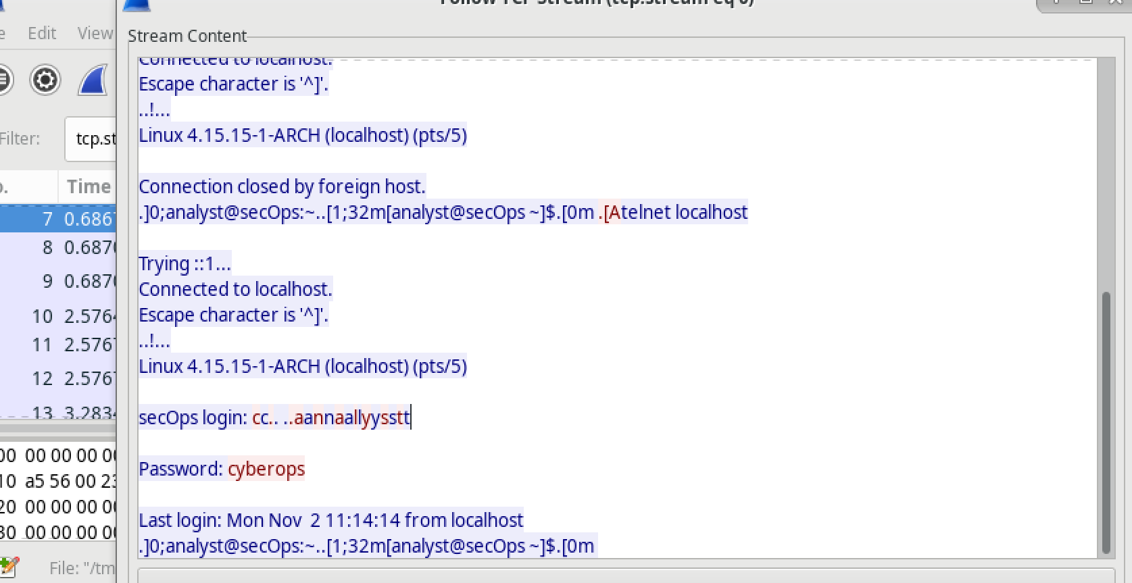

1. Exit telnet session

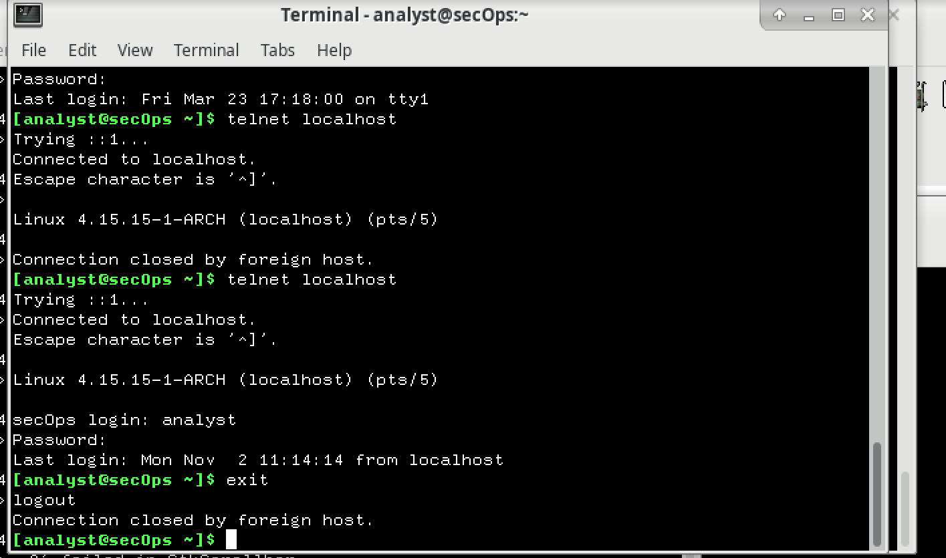

**Part 2: Examine an SSH Session with Wireshark**

1. Start ssh session

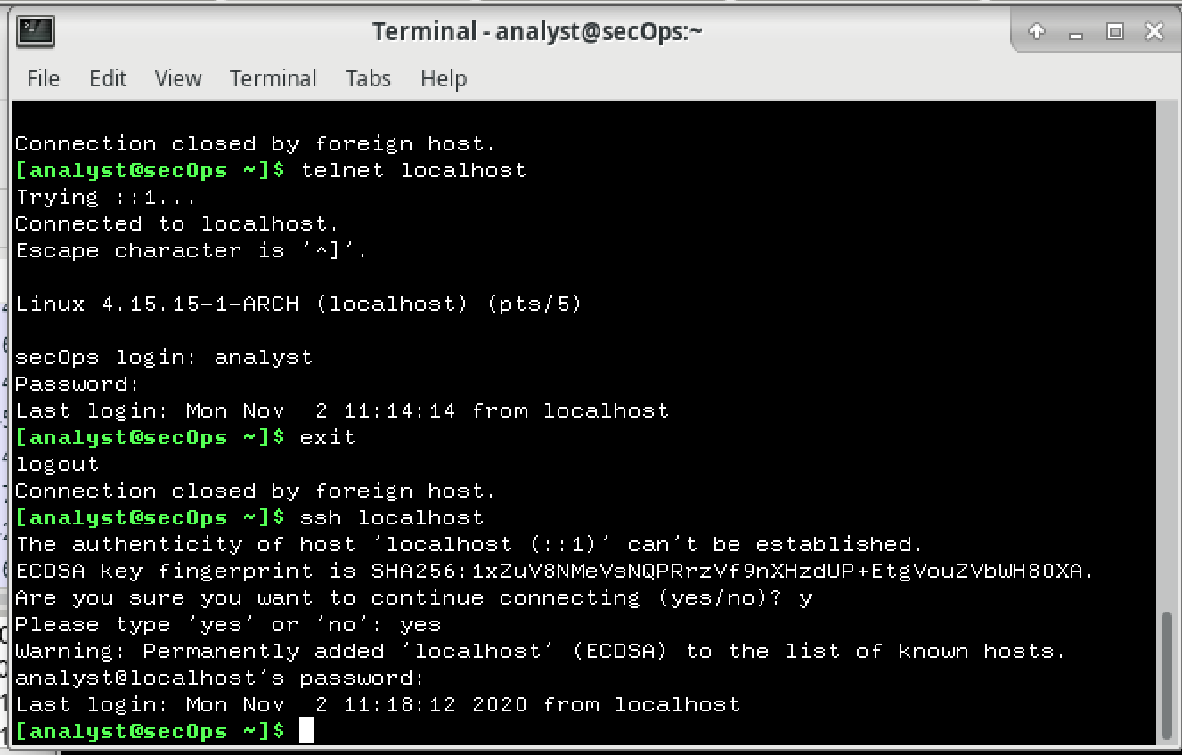

1. Apply ssh filter

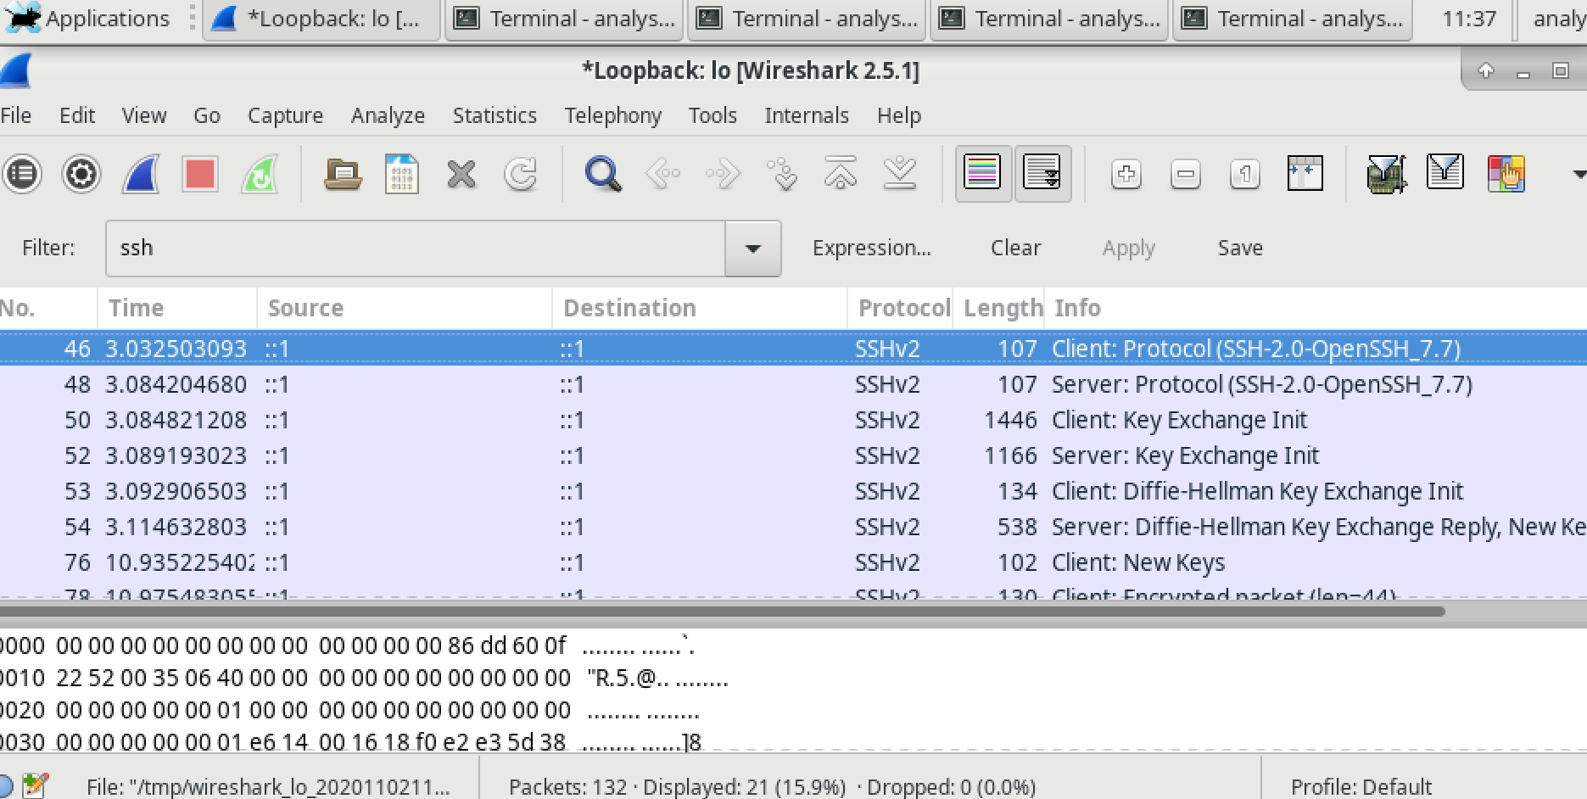

1. SSH session TCP Stream

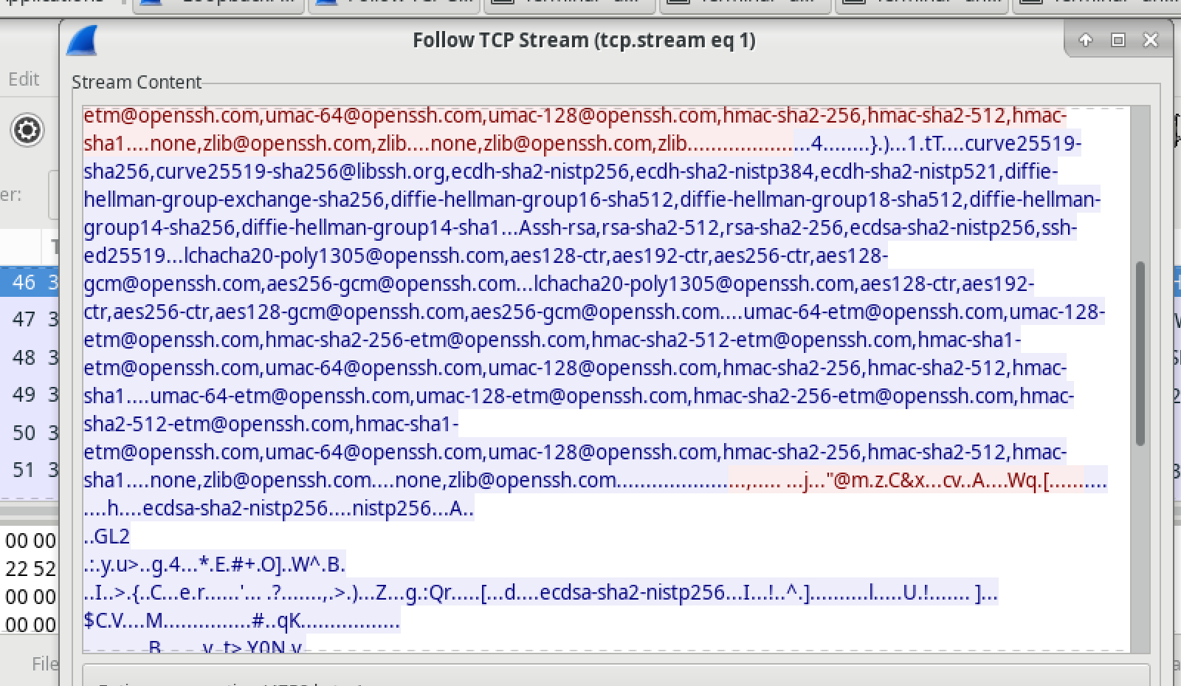

The data in SSH session is encrypted and unreadable, while in telnet we can read login and password.

1. Exit ssh session 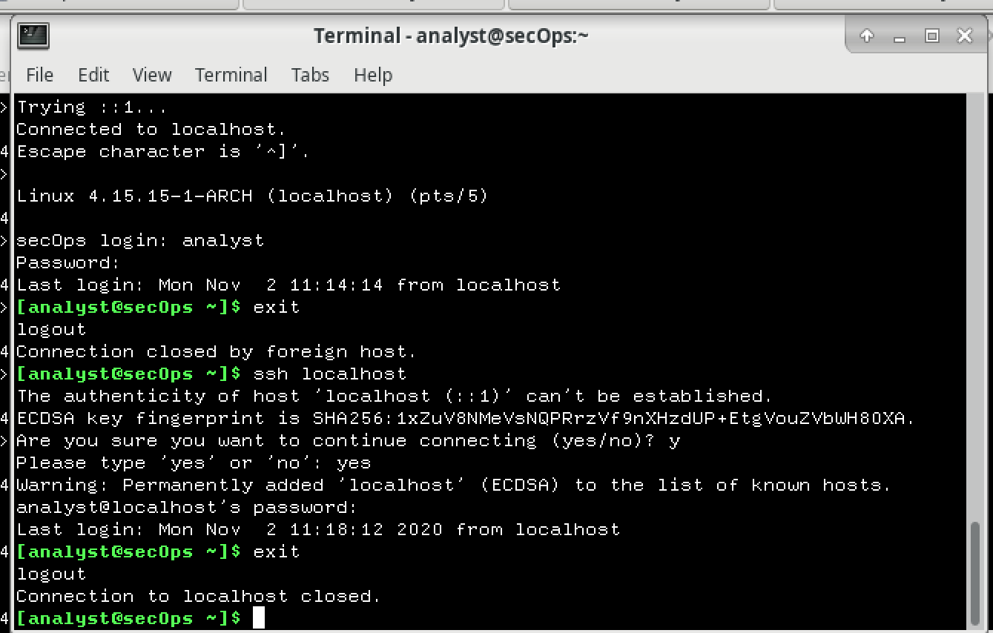

**Reflection**

**Why is SSH preferred over Telnet for remote connections?**

SSH is preferred over telnet because of security issues, telnet doesn't use any encryption therefore the information is transmitted in a form of plain text even the password.

Both are popular for remote login application program.